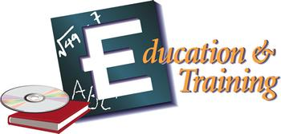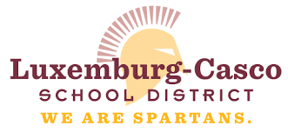
Career Planning Cluster: Education & Training

Foundational Skills Recommended
Oral and Written Communication Skills | Problem Solving |  | Critical Thinking | Leadership
Teamwork | Ethical |  | Legal Responsibility | IT
Health & Environment | Employability |  | Career Development | Safety Focused
Summary
Education and training workers guide and train people. As a teacher, you could influence young lives. You could also support the work of a classroom teacher as a counselor, librarian, or principal. You could coach sports activities or lead community classes. Pathways in this career cluster include administration and administrative support in schools, preschools, child care centers, college, universities or correctional institutions, to professional support services where people assist with mental health, educational goals, or career decision making to teaching and training of individuals and groups of children, adults and professionals.
Career Options
Students interested in education and training can obtain a variety of interesting careers including:
- Superintendent, Principal, Administrator  - Supervisor and Instructional Coordinator  - Education Researcher, Test Measurement Specialist  - College President, Dean  - Curriculum Developer  - Instructional Media Designer  - Psychologist – Clinical, Developmental, Social  - Social Worker  - Parent Educator  - Counselor  - Speech/Language Pathologist and Audiologist  - Substance Abuse and Behavioral Disorder Counselor  - Group Worker and Assistant |  | - Preschool, Kindergarten Teacher, Aide  - Elementary Teacher, Aide  - Secondary Teacher, Aide  - Special Education Teacher, Aide  - College/University Lecturer, Professor  - Human Resource Trainer  - Physical Trainer  - Coach  - Child Care Director  - Child Care Worker  - Child Care Specialist  - Nanny  - Early Childhood Teacher and Assistant

